International Conference
on
Sustainable Computing in Science, Technology & Management
(SUSCOM-2020)
January 20 - 22, 2020 | Amity University Rajasthan, Jaipur, India

Submission Guidelines for Authors

- Open the easy chair link: To be provided soon.
- Type your easy chair user name and password. If you don’t have easy chair account then “Create an account” and follow the steps.

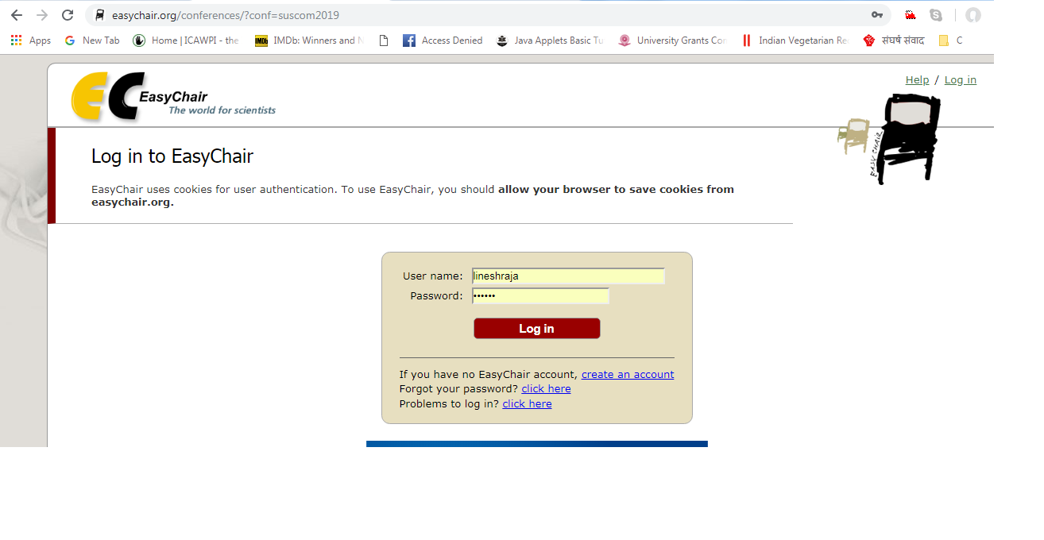
- To submit the paper click on “enter as an author”.

- Start with “New Submission for SUSCOM-2020”. Enter the following information’s:

  - Author Address
  - Author Information
  - Title and Abstract
  - Keywords
  - Topics

- Important instructions regarding Point 4.e:
- Please select topics relevant to your submission from the list.
- If paper belongs to any track, kindly select the track sub title.

